**Module : Microservices - Hands On**

**Note : The editor used is VSCode and not Eclipse**

**Hands-On 1: Create Two Microservices (Account & Loan)**

**Objectives**

This hands-on project aims to:

* Demonstrate creation of multiple independent **Spring Boot Microservices**.
* Understand microservices concept using RESTful APIs.
* Handle port conflicts by configuring services to run on different ports.
* Implement and test simple REST endpoints using **Spring Boot**.
* Learn service separation and independent deployment.

**Tools Used**

* Java 17
* Maven
* Spring Boot
* VS Code
* Postman / Web Browser for API Testing

**Procedur**

**Phase 1: Setup Microservices Workspace**

* **Location**:  
  D:\<EmployeeID>\microservices\
* Created two separate projects inside:
* D:\<EmployeeID>\microservices\account
* D:\<EmployeeID>\microservices\loan

**Phase 2: Account Microservice**

**Step 1: Project Generation**

* Website: [https://start.spring.io](https://start.spring.io/)
* Configuration:
  + Group: com.cognizant
  + Artifact: account
  + Dependencies:
    - Spring Web
    - Spring Boot DevTools

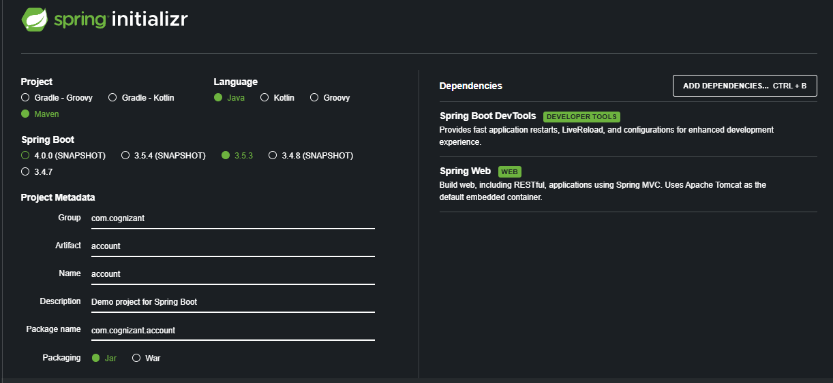

* Downloaded and extracted to:  
  D:\<EmployeeID>\microservices\account

**Step 2: Build and Import**

* Opened in VS Code using:  
  **File > Open Folder > D:<EmployeeID>\microservices\account**
* Built using:

mvn clean package

**Step 3: Implement REST Controller**

* Created package:  
  com.cognizant.account.controller
* Created class:  
  AccountController.java

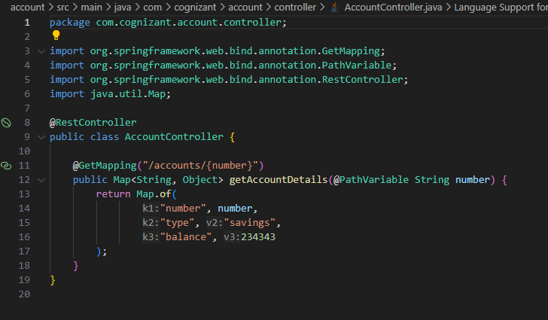

**Step 4: Run & Test**

* Ran service:

mvn spring-boot:run

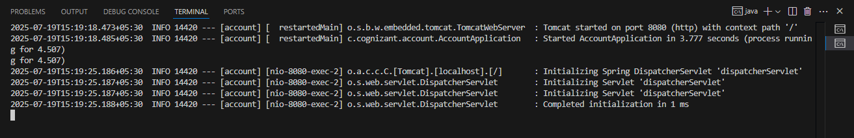

* Tested API:

http://localhost:8080/accounts/00987987973432

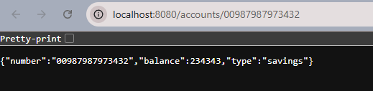

**Phase 3: Loan Microservice**

**Step 1: Project Generation**

* Website: [https://start.spring.io](https://start.spring.io/)
* Configuration:
  + Group: com.cognizant
  + Artifact: loan
  + Dependencies:
    - Spring Web
    - Spring Boot DevTools

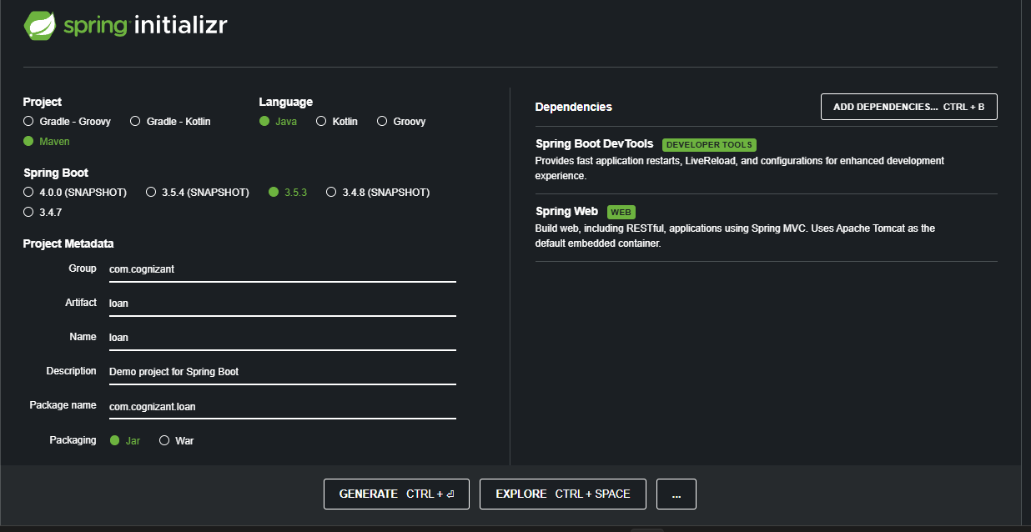

* Extracted to:  
  D:\<EmployeeID>\microservices\loan

**Step 2: Port Configuration**

* Modified src/main/resources/application.properties:

server.port=8081

**Step 3: Implement REST Controller**

* Created package:  
  com.cognizant.loan.controller
* Created class:  
  LoanController.java

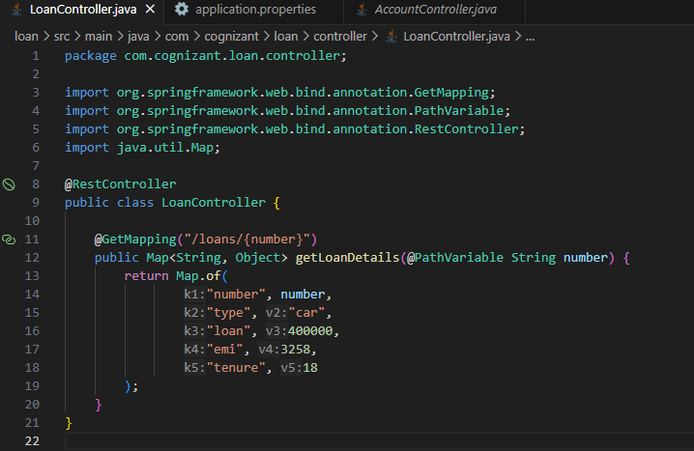

**& Test**

* Ran service:

mvn spring-boot:run

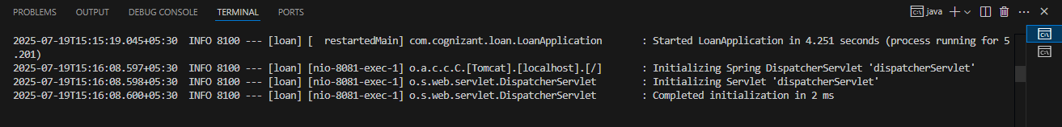

* Tested API:

http://localhost:8081/loans/H00987987972342

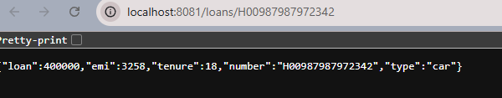

Both the microservices together :

